**FINAL PROJECT REPORT**

**ON**

**“Online food delivery system”**

**in**

**computer science & engineering**



**Submitted to: -**

Er. Ranjit Singh

**Submitted By: -**

Md Adnan Hussain(20BCS9812)

Naina Baghel(20BCS9819)

Gautam Kumar(20BCS9807)

Kumar Suyash(20BCS9842)

**Table of Contents**

**Topic**

Certificate

Student’s Declaration

Acknowledgement

Abstract

**CHAPTER 1: INTRODUCTION**

* 1. Theoretical explanation
  2. Benefits of Project
  3. Software and Hardware tools required for project
  4. Objective

**CHAPTER 2: MATERIAL AND METHODOLOGY**

**2.1** Proposed work

**2.2** Static Page

**2.3** Team work

**CHAPTER 3: RESULTS AND SNAPSHOTS**

**3.1** Result

**3.2** Snapshot

**CHAPTER 4: CONCLUSION AND FUTURE SCOPE**

**4.1** Future Scope

**4.2** Conclusion

**REFERENCES**

**CERTIFICATE**

This is to certify that the work embodied in this Project Report entitled **“ONLINE FOOD DELIVERY SYSTEM”**, being submitted by “20BCS9812, 20BCS9819, 20BCS9807, 20BCS9842” for the degree of **“ Bachelor of Engineering in Computer Science & Engineering ”discipline in “Chandigarh University”** during the academic session JAN-JUNE 2021 is a record of bona fide piece of work, carried out by student under my supervision and guidance in the **“ Department of Computer Science & Engineering ”, Chandigarh University.**

**DECLARATION**

We, student of Bachelor of Engineering in Computer Science & Engineering, Chandigarh University, hereby declare that the work presented in this Project Report entitled “ONLINE FOOD DELIVERY SYSTEM” is the outcome of our own work, is bona fide and correct to the best of our knowledge and this work has been carried out taking care of Engineering Ethics. The work presented does not infringe any patent work and has not been submitted to any other university or anywhere else for the award of any degree or any professional diploma.

**ACKNOWLEDGEMENT**

We would like to express our deep and sincere gratitude to our Project In charge **ER RANJIT SINGH** for giving us the opportunity to do the project and providing valuable guidance throughout this research. Their dynamism, vision and exquisite efforts have deeply inspired us. They taught us the methodology to carry out the research and to present the research work as clearly as possible. It was a great privilege for us to study and work under their guidance.

We thank for the completion of our project to our project Mentor (Milanjit Kaur and Ranjit Singh) for their continuous support and guidance.

* **INTRODUCTION: -**
* This project is designed so as to be used by customers to Order Food Online without rushing to restaurant which consumes a lot of time and energy.
* It is a system through which customers can view available food, place an order and can view profile, menu, contact us, gallery etc.
* The advancement in Information Technology and internet penetration has greatly enhanced various business processes and communication between companies (services provider) and their customers.
* This application takes information from the customers through filling their details in a form.
* This automated system facilitates customer and provides to fill up the details according to their requirements. It includes type of food they want to order and their address. The purpose of this system is to develop a web site for the people who can place an order along with requirement from any part of the world.
* **BENEFIT OF ONLINE FOOD DELIVERY: -**
* This saves a lot of time, money and energy.
* Increases job opportunities.
* Eco-friendly: The monitoring of the vehicle activity and the overall business becomes easy and includes the least of paper work.
* **SOFTWARE AND HARDWARE USED: -**
* **SOFTWARE: -**
* **HTML :**
* HTML stands for Hyper Text Markup Language**.** It is the standard markup language for creating Web pages**.** It describes the structure of a Web page**.** It consists of a series of elements. HTML elements tell the browser how to display the content**.** HTML elements label pieces of content such as "this is a heading", "this is a paragraph", "this is a link", etc.
* HTML is the standard markup language for documents designed to be displayed in a web browser. It can be assisted by technologies such as Cascading Style Sheets (CSS) and scripting languages such as JavaScript.
* **CSS :**
* CSS stands for Cascading Style Sheets. CSS describes how HTML elements are to be displayed on screen, paper, or in other media. CSS saves a lot of work. It can control the layout of multiple web pages all at once. External stylesheets are stored in CSS files.
* **JAVASCRIPT :**
* JavaScript often abbreviated as JS, is a programming language that conforms to the ECMA Script specification. JavaScript is high-level, often just-in-time compiled, and multi-paradigm. It has curly-bracket syntax, dynamic typing, prototype-based object-orientation, and first-class functions.
* Alongside HTML and CSS, JavaScript is one of the core technologies of the World Wide Web. JavaScript enables interactive web pages and is an essential part of web applications.
* The vast majority of websites use it for client-side page behavior, and all major web browsers have a dedicated JavaScript engine to execute it.
* **PHP**
* PHPis a general-purpose scripting language that is especially suited to web development. It was originally created by Danish-Canadian programmer Rasmus Lerdorf in 1994; the PHP reference implementation is now produced by The PHP Group. PHP originally stood for Personal Home Page, but it now stands for the recursive initialism PHP*:* Hypertext Preprocessor.
* **MY SQL :**
* SQL is a standard language for accessing and manipulating databases. SQL stands for Structured Query Language. SQL lets you access and manipulate databases. SQL became a standard of the American National Standards Institute (ANSI) in 1986, and of the International Organization for Standardization (ISO) in 1987
* SQL can execute queries against a database, retrieve data, insert records in a database, update records ,delete records, create new databases, create new tables in a database, create stored procedures in a database, create views in a database, set permissions on tables, procedures, and views.
* **HARDWARE :**
* Processor (CPU) with 2 gigahertz (GHz) frequency or above
* A minimum of 2 GB of RAM
* Monitor Resolution 1024 X 768 or higher
* A minimum of 20 GB of available space on the hard disk .Internet Connection Broadband (high-speed) Internet connection with a speed of 4 Mbps.
* Keyboard and a Microsoft Mouse or some other compatible pointing device.
* **OBJECTIVE: -**
* The main objective of developing this website is to provide Online Food delivery to customer.
* It takes all the necessary information from the customer through a form in order to receive Food order.
* **STATIC PAGES: -**
* Home Page will contain:
* About us Section which will describe about the restaurant.
* Menu
* Gallery for images of Food.
* Subscription Section
* Contact us
* **MATERIAL AND METHODOLOGY: -**
* Several materials are used to build this project. Certain software interfaces are used like window 8/10, 4 GB ram/ 255GB hdd .Technologies are also used like MY SQL, PHP, for full stack development tools.
* First of all you have to log in to the system.
* New users will sign up and old users will log in to the system.
* Then they will be directed to the home-screen where they can see the list of top cars.
* Here they can search for the cars they want to know about.
* Users can read reviews about the cars after clicking to the read review button.
* Users can add reviews after clicking the add review button.
* Users will also get informed about the rating of the review based on previous customers’ reviews.
* **PROJECT DESIGN: -**
* Managing of the Delivery form
* This describes the proposed system, explaining how modules and components integrate and communicate to bring about the working application of the proposed system. The website
* Design is developed to satisfy the requirement of modern system architecture including computational structures and model training algorithms. The website design will also capture the major functional
* Building blocks needed to understand the process of building a system.
* **Users**
* **Admin**
* **Guest**
* **Guest Users:**

Guest user can view the website and check out the information about food available. Guest users can also inquiry through contact us section.

* **Take order from Users:**

Anyone can Order through the order now page. After a successful form filling user get a notification of “Order Received”. User can reset form before submitting if there is some wrong information added in form.

* **Admin:**
* Admin is the super user of the website who can manage everything on the website. Admin can log in through the login page
* **Admin Features–**
* Admin can add various type of food available in restaurant
* Manage types of food(Edit, Delete)
* Post food items
* Manage (Edit, Delete)
* Manage Booking(Admin can confirm and Cancel Booking)
* Manage Testimonials (Active and Inactive)
* Manage to Contact us Query
* Admin Can get the details of users who ordered
* Admin can also update the page content
* Admin can update the contact us details Manage Subscribers
* Admin can update the contact us details Manage Subscribers
* Admin Dashboard(Admin can view the count of users who ordered food, total orders, total subscribers, total queries, etc)
* **MODEL APPROACH**
* **INTERFACE REQUIREMENTS**

**SOFTWARE INTERFACE**

* Windows 8/10.
* 4 GB ram / 256gb hdd
* MySQL
* Xam
* Html
* JavaScript & PHP
* Several materials are used to build this project. Certain software interfaces are used like window 8/10, 4 GB ram/ 255 GB, MySQL. Technologies are also used like JavaScript for development of the project. MySQL is used for free open source database to store the data.
* **TEAM WORK –**
* Md Adnan Hussain – 1st page Back End, 2nd page Backend ,DATABASE and web dev connectivity.
* Naina Baghel –1st Page front end ,2nd page front end (Desinging Menu section ) , Project report making.
* Gautam Kumar –1st Page front end (Desinging Home page),2nd Page front end.
* Kumar Suyash –1st page front end (designing Suscribe and Contact section),Project PPT making.
* **SNAPSHOT OF RESULT: -**
* **HOME PAGE: -**

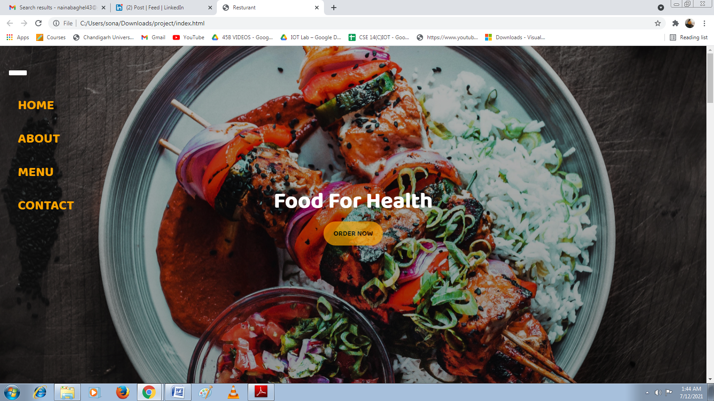

* **DELIVERY FORM: -**

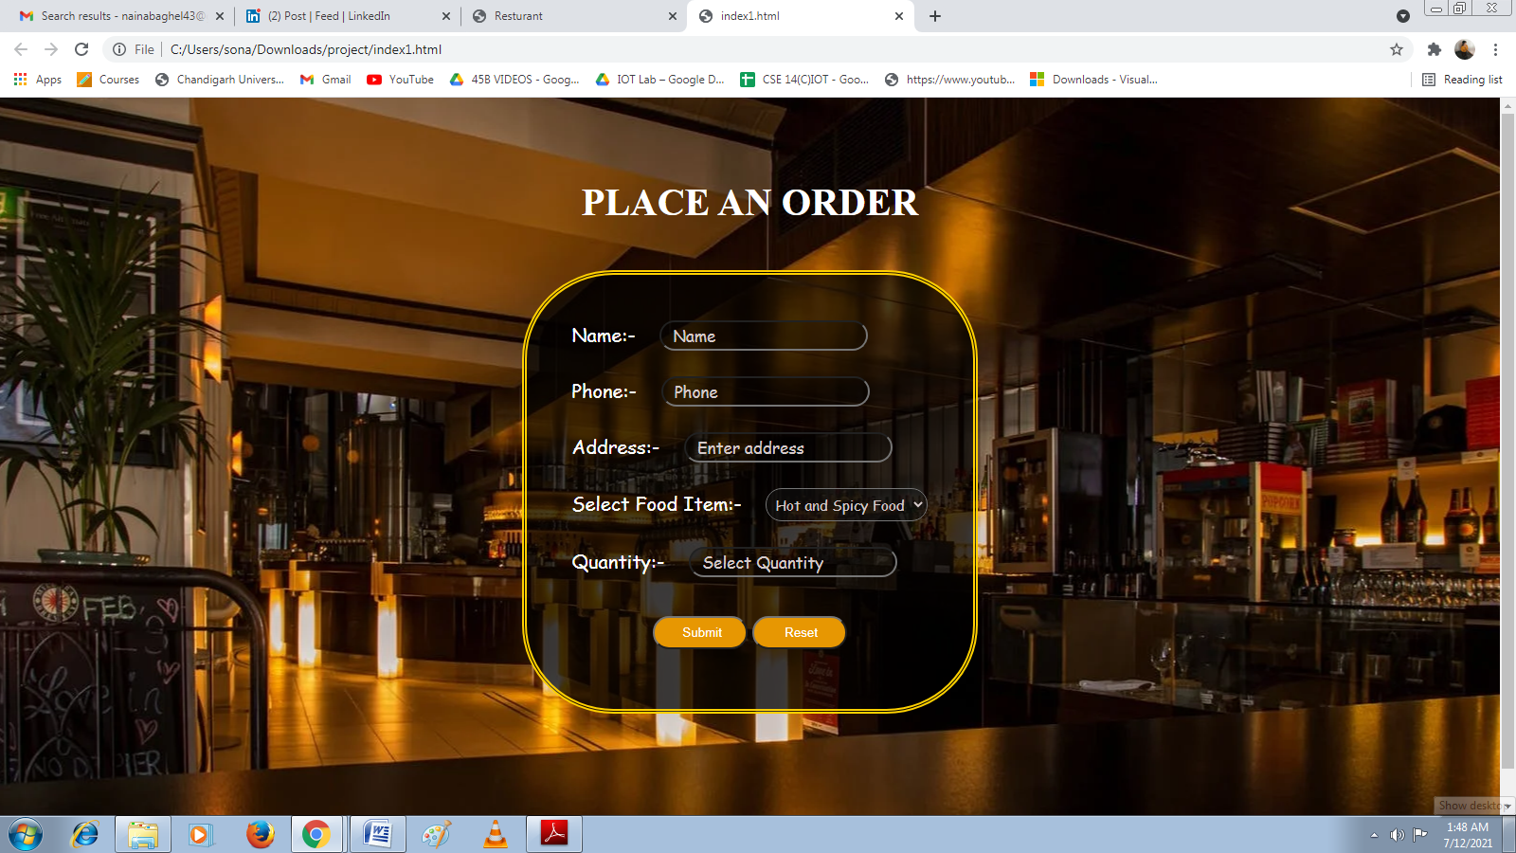

* **ABOUT US: -**

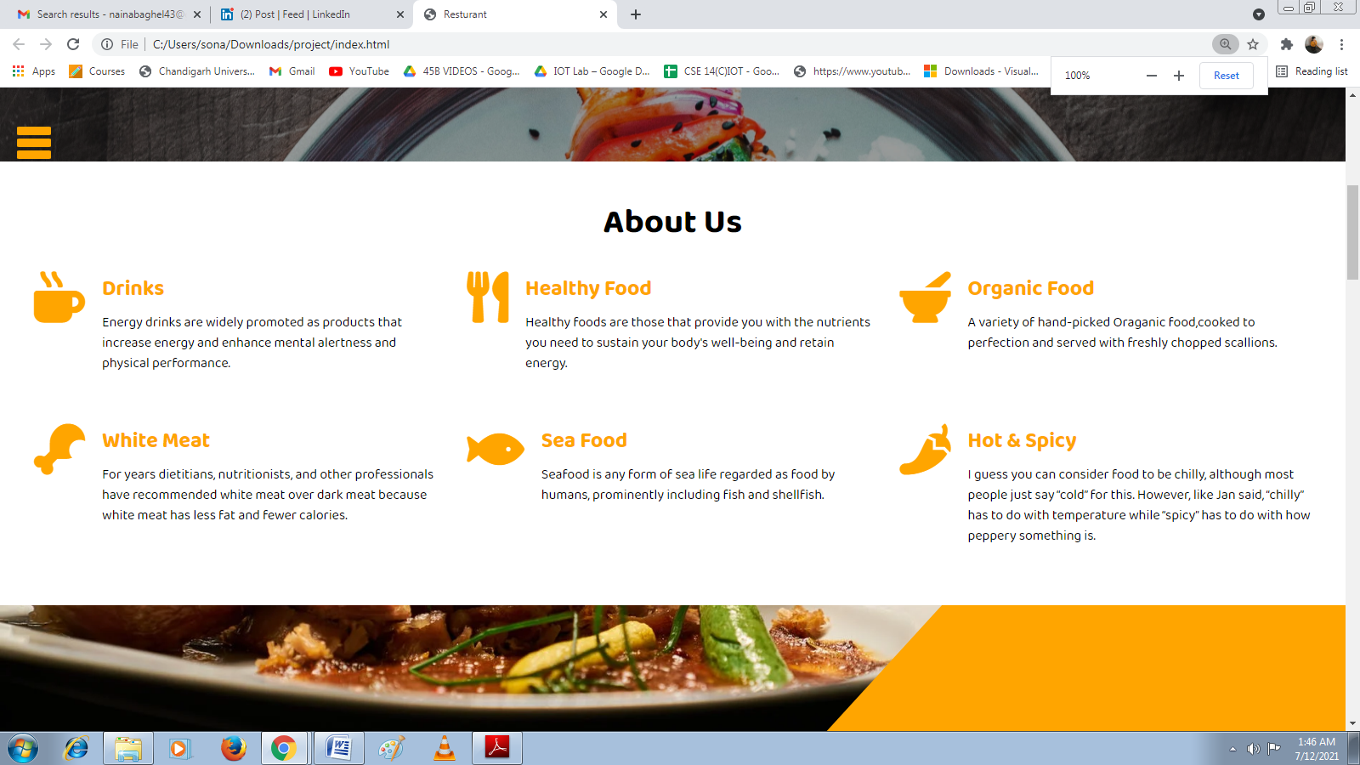

* **FOOD FUSION: -**

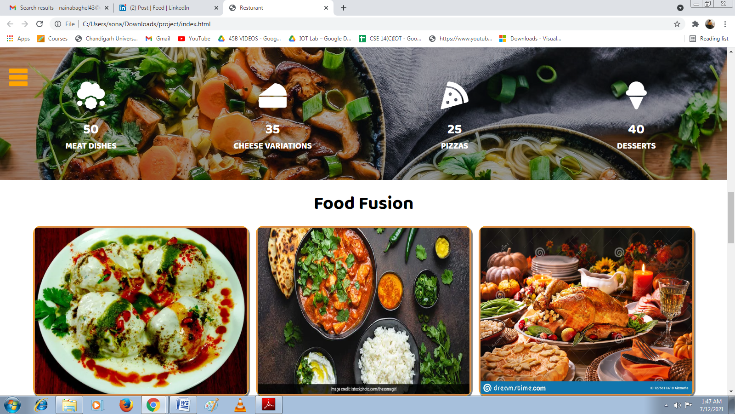

* **GALLERY: -**

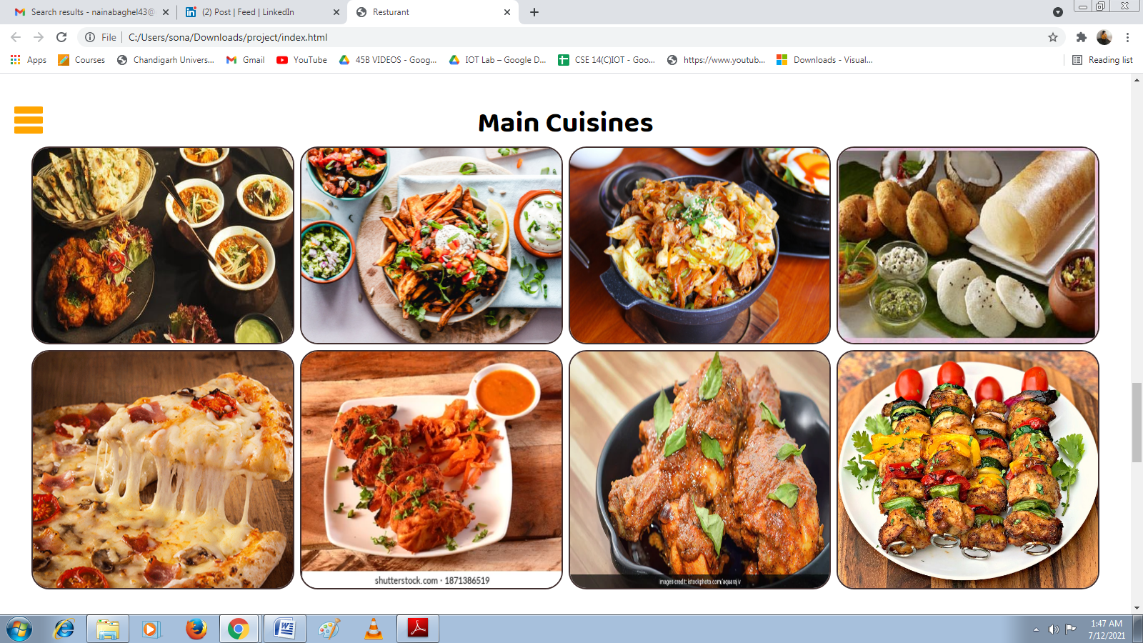

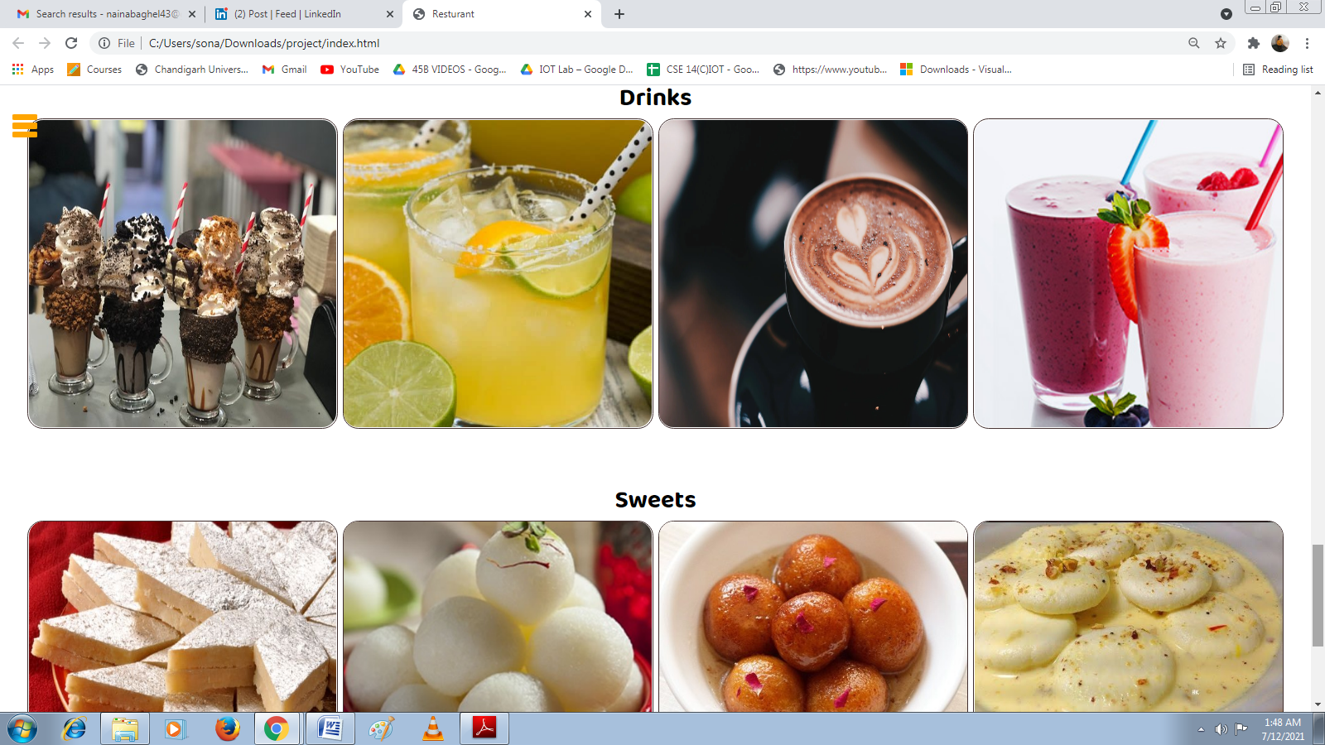

* **SUBSCRIPTION AND CONTACT US: -**

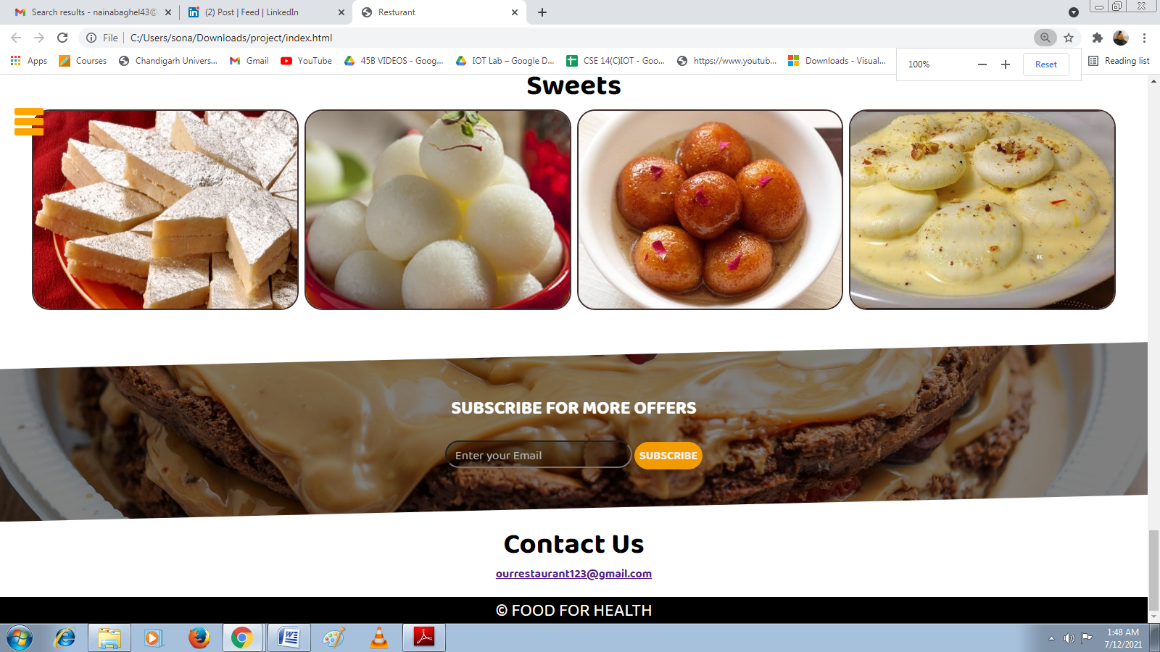

* **CONCLUSION AND FUTURE SCOPE: -**
* Our Project is based on online food delivery which enable customers to order food online through their comfort zone.
* In this pandemic situation no one wants move out of their house to buy food. In this case our online food delivery system helps them to order food online which is safe and also save time of costumer.

* **POSSIBLE FUTURE WORK:**
* Create a backup mechanism for backing up data and information.
* The purpose of Online Food Delivery System is to automate the existing manual system by the help of computerized equipments and full-fledged computer software**.** The main objective of the project is to provide a convenient, user friendly and responsive Food Ordering Website.
* We can give more advance software for online car rental systems and add more facilities.
* We can add printer in the future.
* Integrate multiple load balancers to distribute the load of system.
* Create a backup mechanism for backing up data and information.
* We will host the platform on online servers, to make it accessible worldwide.
* Today, the market place is flooded with several car rental options for shoppers to choose from.
* A variety of innovative products and services are being offered spoiling customers for choice. Online car rental system is no more a privilege enjoyed by your friends and family.
* Today, it is a reality in India. In the last couple of years, the growth of car rental system industry in India has been phenomenal as more shoppers have started discovering the benefits of using this platform.
* There is enough scope for online businesses in the future if they understand the Indian shoppers psyche and cater to their needs.
* **REFERENCES: -**
* W3 Schools Website (<https://www.w3schools.com/>)
* Training’s lecture and ppt
* Youtube